**Adding language routes**

To access the language management, go to teacher management and hit the ‘Website Language Management’ button.

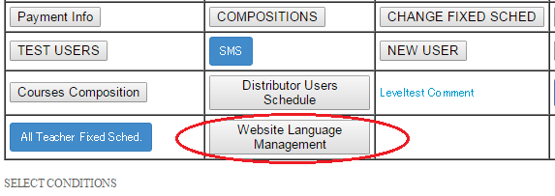

Once clicked, you will be redirect to the Manage Routes Languages page.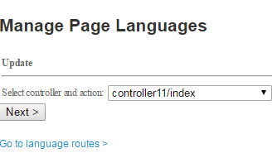

Hit ‘Go to language routes >’ page to enable language translation to a particular page. (assuming the controller and the action is not yet recorded).

Once clicked, you will be redirect to the Language Rotues page.

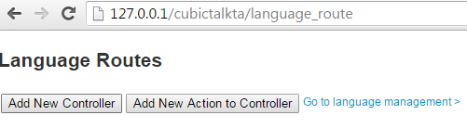To enable language translation to a particular page. Hit the ‘Add New Controller’ button.

Upon clicking the ‘Add New Controller’ button, a text field and a button will apprear.

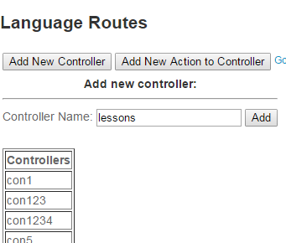

Input the desired controller name (example: ‘lessons’) and hit ‘add’ button.

A table will will also appear displaying all the controllers that have been previously recorded.

Once you click ‘Add’ the controller that you entered will be recorded. You will see it displayed in the table.

3.png

A default action will be created called ‘index’, to add more actions, select the controller you just recently added and type an action (example: ‘teacher_management’).

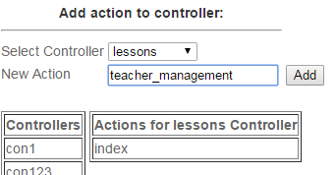

A table named ‘Actions for lessons Controller’ will be also displayed, showing you the actions associated with the controller. Once you have typed the action, simply hit ‘Add’ button to record it.

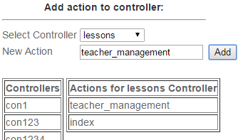

Upon clicking the ‘Add’ button, you will see the action also showed in the table, this only means that the actions have successfully been recorded.

You can do this multiple times if you wanted to add more actions. If you wanted to add new actions to a controller, simply select it on the ‘Select Controller’ dropdown box.

**Adding variables and translations**

Once you have created the controllers and the actions, you are now ready to put in the variables and languages for the pages.

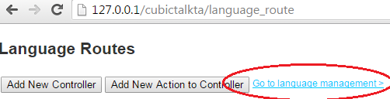

Click on the ‘Go to language management >’ link to proceed.

Once clicked, you will be redirected to Manage Page Languages. Select the controller and the action you wanted to add translations and variables then hit ‘Next >’ button.

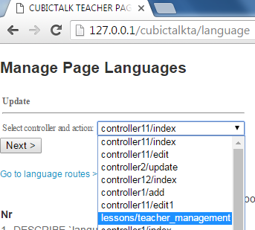

Upon clicking the button, you will be redirected to another page called Manage Languages.

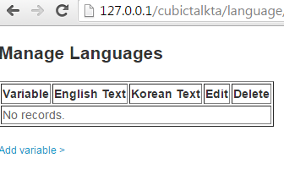

Since the controller and the action we made is brand new, there will be no records to be displayed. To add some, simple hit the ‘Add variable >’ link.

Upon clicking the link, you’ll be redirected to a page that contains a form, which will now enable you to input the variables and the text for different languages.

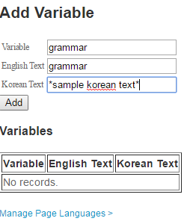

To add a record, type in the variable that will hold the translations and type the values for the variables for different languages then hit ‘Add button’.

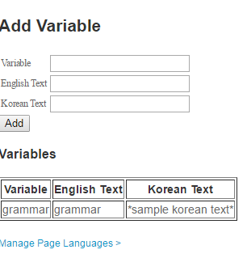

Upon hitting the button, your input will be displayed on the table below, which only proves you have successfully recorded your input.

**Editing variables and translations**

To edit variables and translation, hit the ‘Manage Page Languages >’ link and you will be redirected to the first page.

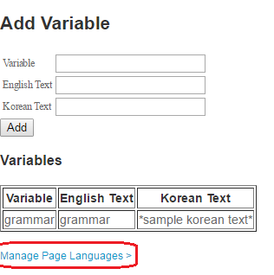

Select the controller and the action you want and hit ‘Next >’ button.



Once clicked, you will redirected to Manage Languages. You will see the input you entered last time, to edit the values. Hit the ‘Edit Translation’ link.

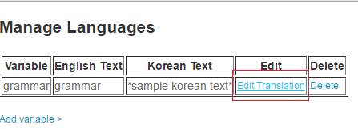

Once clicked, you’ll be redirected to another form containing the inputs, simple type another values and hit ‘Save’ button to change them.

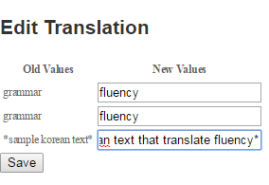

As you can see, I am changing the values for my last input, the old record was variable grammar and now I’m changing it to fluency and same with other values.

Once you clicked save you will be redirected back to the list of values for the controller and action, thus, you will the changes you made.

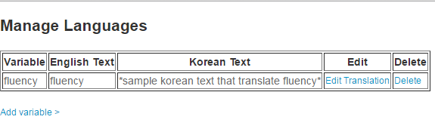

**Editing variables and translations**

To delete a variable and a translation, simply hit the ‘delete link’.

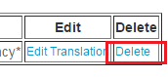

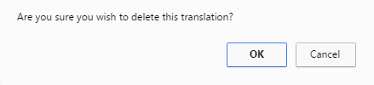

You will be asked for confirmation, if you’re sure, hit ok and the record will be gone.

~ FIN